**Store Sales**

|  |  |
| --- | --- |
| Work | Team Name |
| Analysis Questions, Insights | Zeyad Mohamed Ali Shokry |
| Processing data | Demiana Ayman Gerges |
| Processing data | Mohamed Makki Abdelaal |
| Visualization | Mohamed Hamdy El Sayed |
| Analysis Questions, Insights | Rania Maher Nageh |

* **NoteBook Work:**
  + **Read Data**
  + **Get some information about the data**
  + **Data Cleaning**
    - Remove Duplicates
    - Get the postal code of Vermont state from google -----> 05401 , and fill the nulls by it
    - Change the type of Order Date and Ship Date columns from object to date
    - Change the type of Postal Code column from float to integer
* **Insghits:**

1- Top ten city by sale

2- Top ten States by sale

2- plot the region with highest sales of products

3- the top 10 products

4- the lowest 10 products

5- the highest category

6- best category with sales

7- the year_order_date with sales -> product

8- Sales Distribution by Customer Segments

9- Top Spenders Analysis and Shipping Mode Distribution -> targets products for any spender type

10- analysis Region By Ship mode(classes)

11- how long the product take (ship - order) date -> relationship with sales

* **Visualization and Results**: A bar chart with different colored squares

  Description automatically generated
* Result : Most of the Orders in Category are Office Supplies

* Result : Ship Mode of most of the Orders is Standard Class



* Result : Most of the Sales are from Technology Products

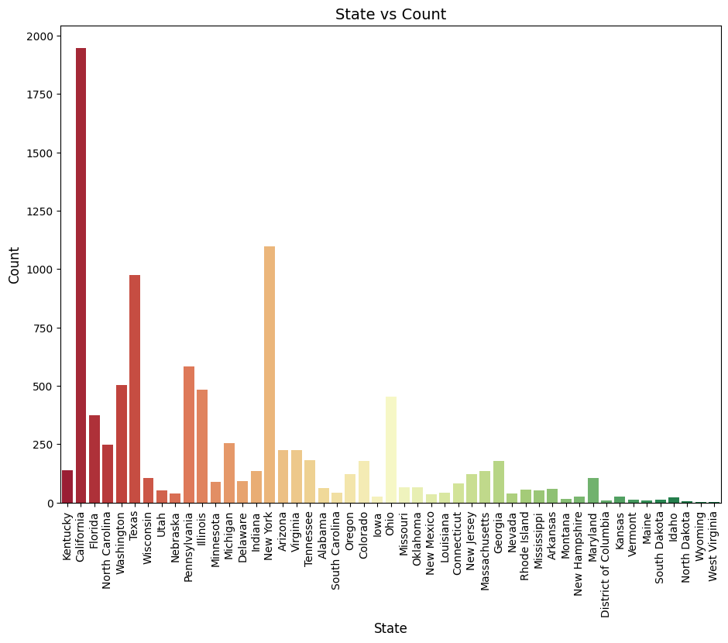

* Result : Most of the Orders are from California and New York States

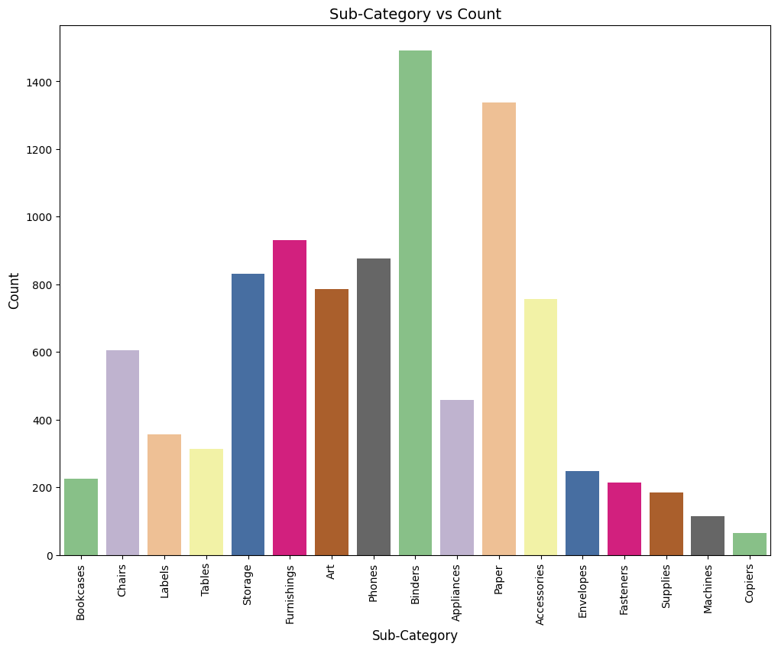

* Result : Most of the Orders in Sub_Category are Binders and Papers

* Result : Most of the Sales are from New York City and Los Angeles

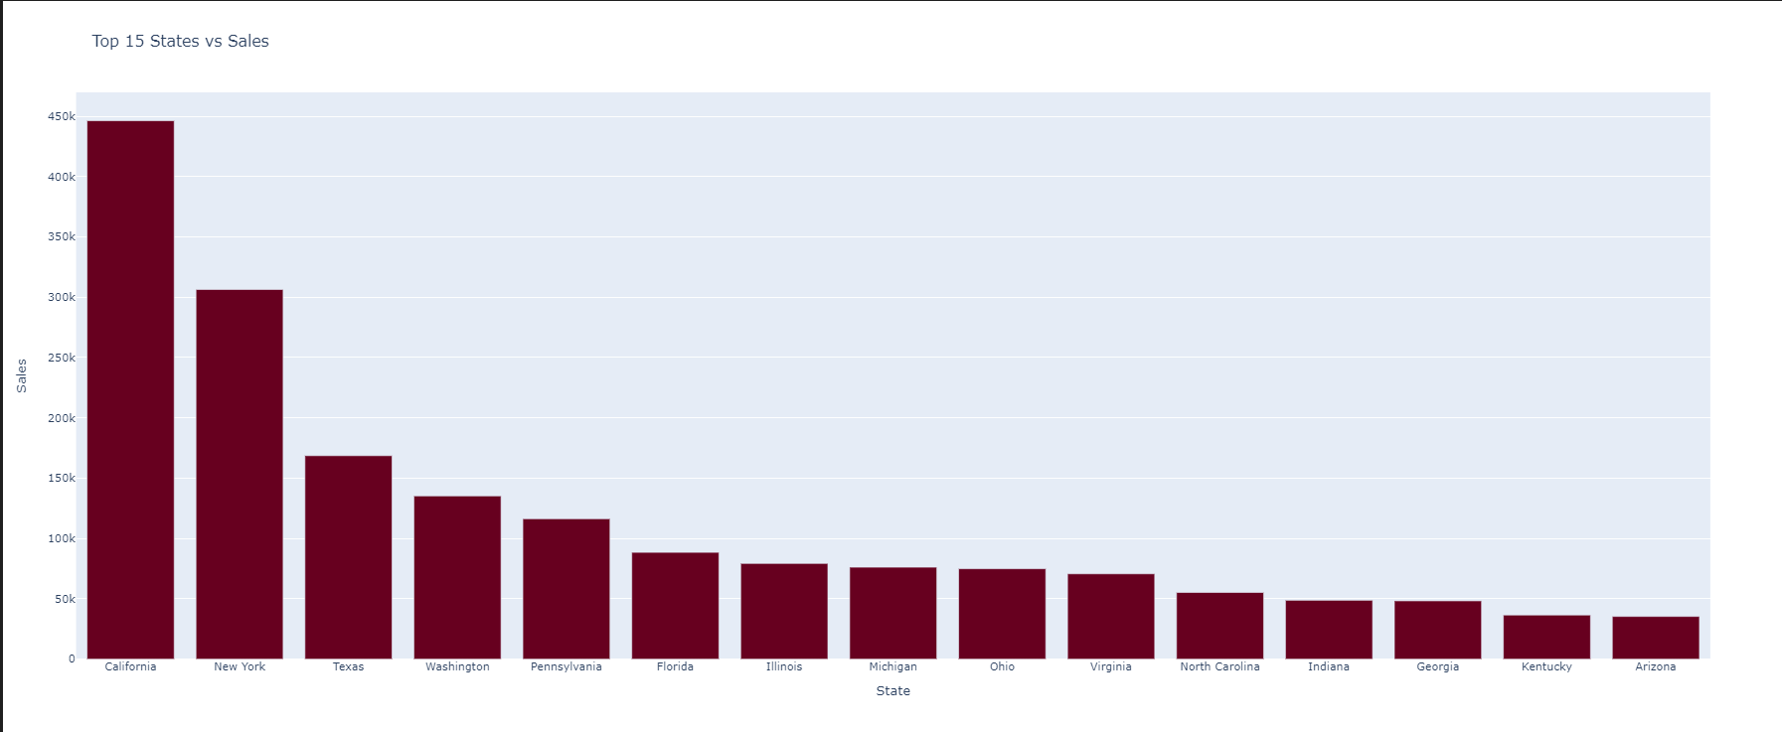

* Result : Most of the Sales are from California and New York States

* **Results:**

- Ship Mode of most of the Orders is Standard Class

- Most of the Orders are from Consumers

- Most of the Orders in Category are Office Supplies

- Most of the Orders in Sub-Category are Binders and Papers

- Most of the Orders are from California and New York States

- Most of the Sales are from California and New York States

- Most of the Sales are from New York City and Los Angeles

- Most of the Sales are from Technology Products

- Most of the Sales are from Consumers

- Most of the Sales are from West Region

- The Canon imageCLASS 2200 Advanced Copier Product acheived the most Sales

* **Conclusions:**

***Which Country have the highest and lowest sales, and what factors could explain this ?***

* To determine which country has the highest Sales :
* California : Often leads in various markets due to a large population, high consumer spending power, and a strong economy.
* Factors Explaining These Trends:
* Economic Conditions: Wealthier countries tend to have higher disposable incomes, driving sales.
* Market Size: Larger populations increase potential customer bases.
* Consumer Behavior: Cultural factors and consumer preferences influence purchasing decisions.
* Infrastructure: Developed logistics and distribution networks facilitate higher sales in wealthier nations.
* Technological Access: Countries with better access to technology can drive e-commerce and sales.

***Points that need clarification or modification:***

Global Financial Crisis: The global financial crisis occurred mainly between 2007 and 2009, not in 2015. Its effects lasted for several years, but the US economy was already in recovery by 2015.

Unemployment: Although unemployment rose significantly during the crisis, it began to decline significantly after that, reaching historically low levels in recent years before the Corona pandemic.

***The US market has been in a deficit since 2015 for several reasons:***

* Economic slowdown: The economy was still recovering from the effects of the 2015 financial crisis, which affected consumer confidence.
* High interest rates: In some periods, interest rates increased, which reduced borrowing and spending.
* Trade tensions: Trade disputes with countries such as China led to uncertainty in the market, which affected investments and sales.
* From 2016 until now, sales have started to rise due to:
* Improved economy: Growth in jobs and increased wages increased consumer confidence.
* Declining unemployment rates: Job opportunities increased, which boosted purchasing power.
* Stimulus policies: Fiscal policies such as tax cuts and increased government spending were implemented to support growth.
* Shift in consumer patterns: Changes in purchasing habits, such as the shift towards e-commerce, also contributed to increased sales.
* Less tax payments on purchased sales, which led to increased sales
* These factors combined led to a recovery in the market and a significant increase in sales.